Size Standard
Try to locate these in your gel

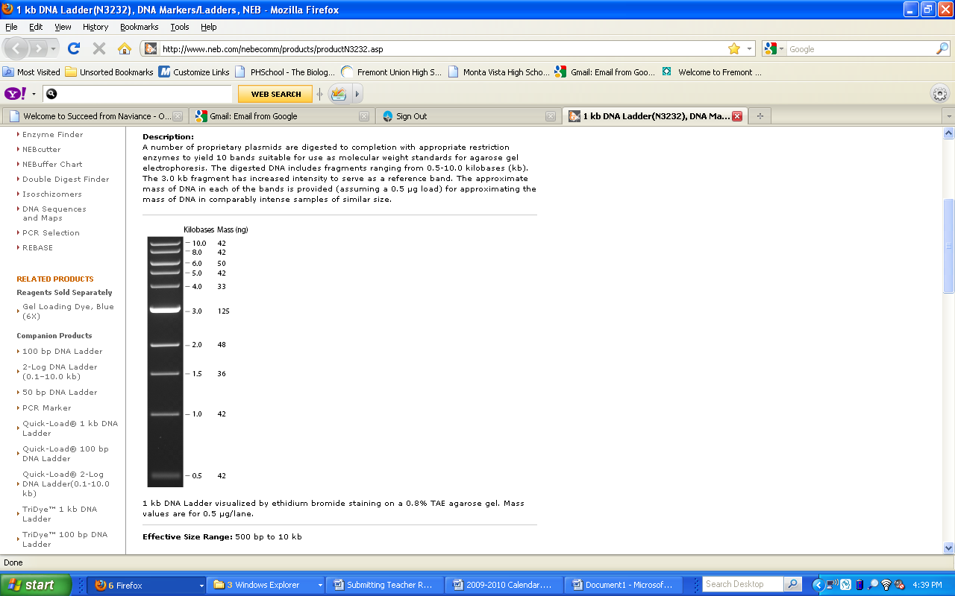
Try to locate these fragments in your gel

